Output for Task1 and Task2

1.Addition of item to database.(POST API)

command = http://localhost:35622/add-item

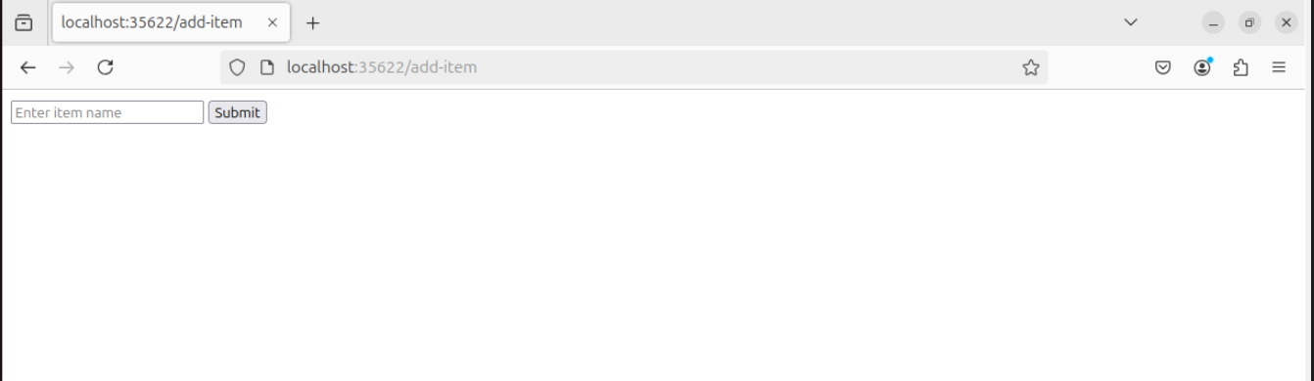

1. Enter the item and press enter to process that request.

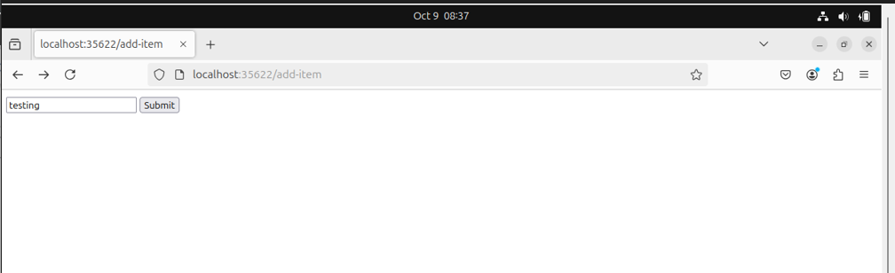

1. Once you press the enter , the item is automatically added into database.

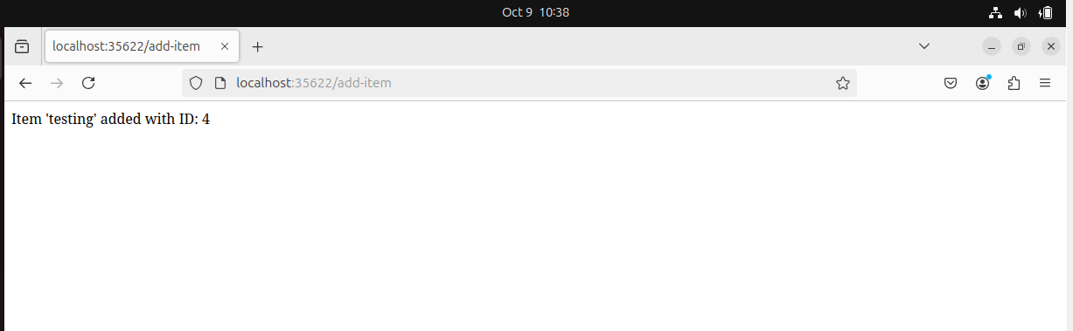

1. Reading the data from the database.(GET API).

command = <http://localhost:35622/xyz/items>

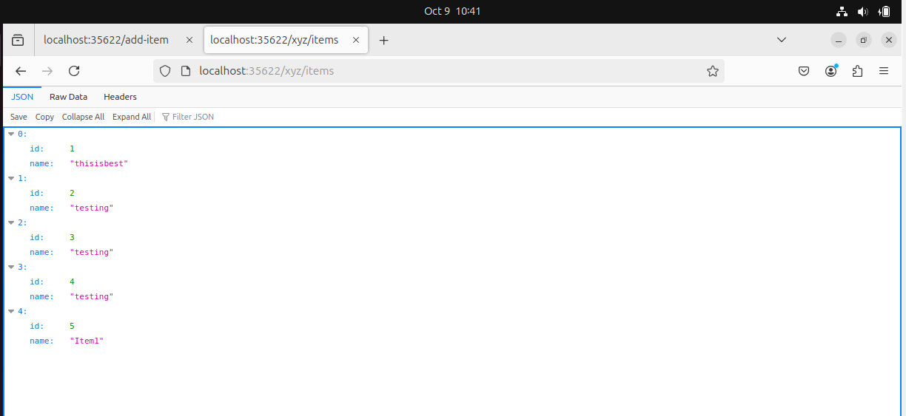

1. Accessing the Application

Command = <http://localhost:35622/xyz>

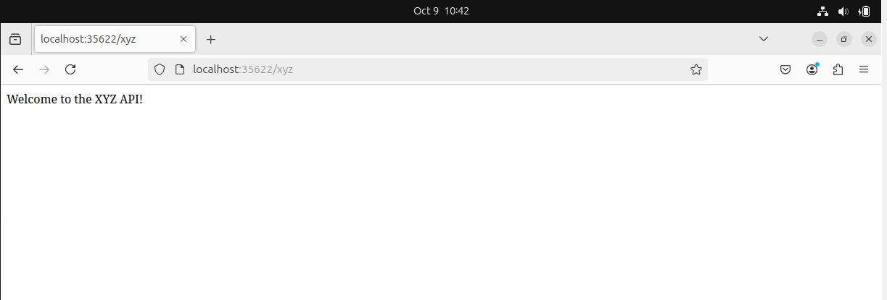

1. verifying the database mysql.

Login to mysql database (commad = docker exec -it container-name mysql -u user -p)

After this it will ask the password - please enter the password which is set in the yml file.(password)

Once it get logged in , please use the mydatabase for querying (command = use mydatabase;)

Check the data in the database (command = select \* from item;)

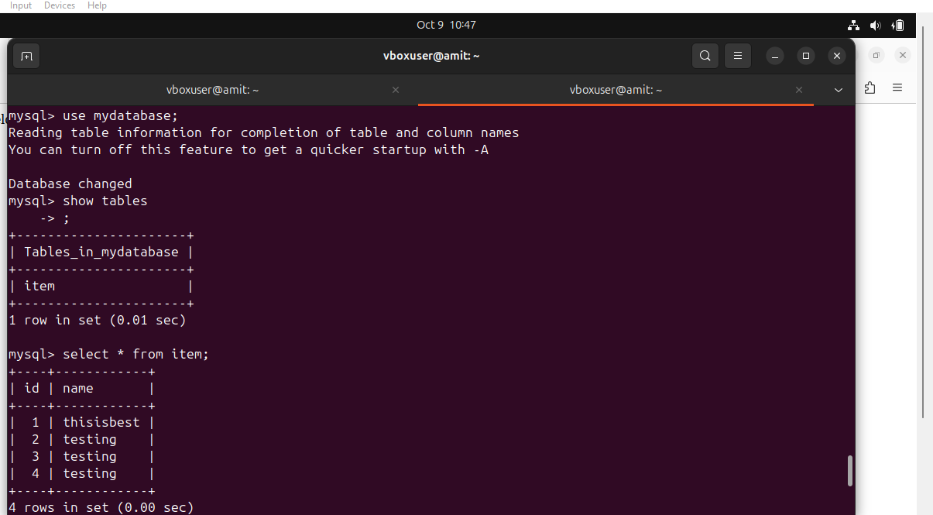

You can also test with curl command also.

Below are the curl command which are for POST and GET and for accessing the application.

1. POST API.

Command = curl -X POST [http://localhost:35622/xyz/add](http://localhost:35622/xyz/add" \t "https://mail.google.com/mail/u/1/" \l "inbox/_blank) -H "Content-Type: application/json" -d '{"name": "Item1"}'

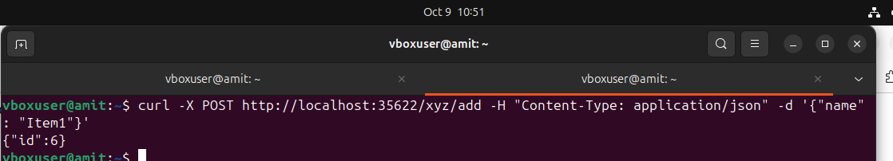

1. GET API.

Command = curl -X GET [http://localhost:35622/xyz/items](http://localhost:35622/xyz/items" \t "https://mail.google.com/mail/u/1/" \l "inbox/_blank)

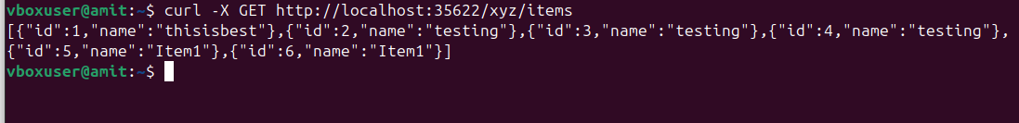

1. Accessing an application.

Command = curl -X GET [http://localhost:35622/xyz](http://localhost:35622/xyz" \t "https://mail.google.com/mail/u/1/" \l "inbox/_blank)

